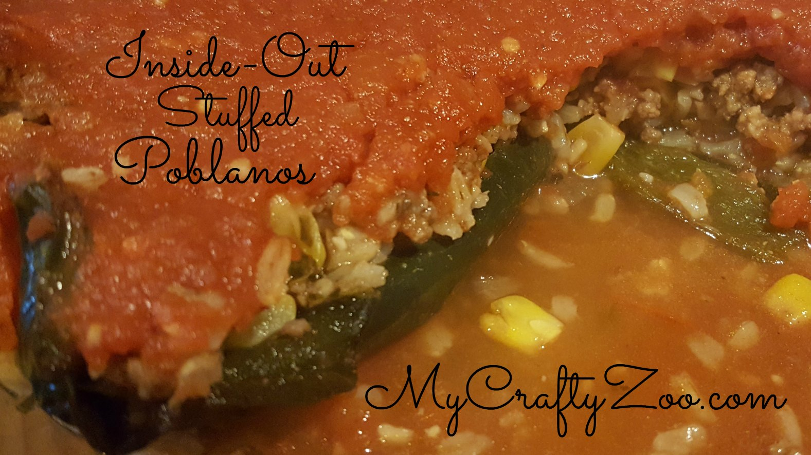Inside-out stuffed Poblanos
This yummy recipe is perfect to mix things up a bit! With healthy and delicious ingredients, it’s sure to become a new family favorite!

Ingredients
5 | Poblano Peppers
2 c | Chopped onions
2 Tbsp | Minced Garlic
1 lb | Ground Turkey
1 c  1 c  1 can  1 Tbsp  ¼ c | Cooked Brown Rice  Corn  Tomatoes  Cumin  Lime Juice  Cheese (opt)

- Line cookie sheet with foil. Broil peppers for 6 minutes, turn over and broil 6 more minutes.
- Sauté onion with garlic, set aside.
- Cook ground turkey, drain.
- In a food processor or blender, combine ½ of onion mixture, tomatoes, cumin and lime juice. Blend until smooth.
- In a large bowl, mix 1 ½ c rice, ½ onions, gr beef, corn and part of the tomato mixture. Mix in some cheese if desired.
- Spray baking dish with non-stick spray, slice and seed peppers then spread them across the bottom of the pan.

- Spread meat mixture across peppers, top with tomato mixture.
- Bake at 400 degrees for 20 minutes.
*if you’d like to add cheese on top, add it about 4 minutes before the peppers are done.

Thank you for visiting MyCraftyZoo.com It means the world to us!

